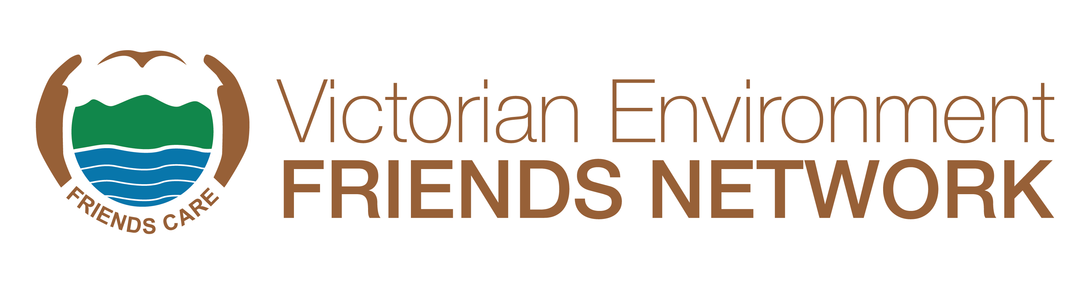
YOUNG BEST FRIEND AWARD 2024
About the Category
The Young Best Friend Award is intended for young people who are “giving it a go” and getting involved with their local environment, so that they make a difference.
Who can be Nominated
There are two awards:
- The first is for young volunteers who are 15 to 21 years of age as of June 30th, 2023, who are regarded by members of the nominating group as passionate for the environment, volunteer regularly, and have demonstrated that they have learnt environmental skills, such as tree planting, weeding and litter collection, as part of the Friends group activities.
- The second is for children aged 14 or younger, who are regarded by members of the nominating group as passionate for the environment, volunteer regularly, and have demonstrated that they are learning environmental skills, such as tree planting, weeding and litter collection, as part of the Friends group activities.
Judging Panel
All nominations will be assessed by the judging panel according to the criteria listed below. Nominations should demonstrate that the nominee meets these criteria and/or those they consider make them an exceptional Young Best Friend. The judging panel may make a special case for additional awards in the event of many exceptional candidates being nominated.
Completing the Nomination Form
The nomination form must be completed and signed by an office bearer or recognised representative of the nominating Friends group.
Please read the Selection Criteria carefully to ensure that your nomination is relevant. Please provide up to the allocated number of words for each Selection Criteria. Be specific about the scale and impact of the nominee’s contribution. A cursory response of a few lines with insufficient supporting material to enable a thorough assessment of the nominee will not be sufficient for the nomination to be considered. The quality and adequacy of information in the nomination form and attachments will have a bearing on the outcome. That is, it is not just what the nominee has achieved, but how well the information is understood and presented, that will allow the judges to assess the nomination and make their decision on each nomination.



Selection Criteria
The nominee will have made an outstanding contribution under some or all the following five criteria or other areas that the nominating group consider demonstrate their contribution:
- Show an interest in the environment and attend planting and maintenance activities regularly, and enthusiastically participate.
- Demonstrate that they have learnt and can practice environmental skills, such as tree planting, weeding, litter collection or other relevant activities as part of the Friends group work.
- Show leadership, such as bringing their friends or family to the group’s activities or taking the lessons they have learnt back to their school or university.
- Show personal dedication to environmental volunteering.
- Communicate the value of the environment and environmental volunteering, including through websites, blogs, videos, and social media.
Number of Nominees
While it is anticipated that there will be only one nominee per group, in some circumstances it is recognised that more than one young volunteer may have made an outstanding contribution to the environment. In this case, more than one nominee per group will be considered. The nominee must be a paid-up member of the nominating group. The nomination form must be completed and signed by an office bearer or recognised representative of the nominating Friends group.
Length of Service
It is expected that all nominees for Young Friends awards will have had regular involvement in the work of the group over a period of at least one year.
Referees
All nominations must include two (2) written references, including from the agency land manager on their letterhead, where Friends groups work with an agency or state or local government.
Recent Photograph of the Nominee
At least one high resolution (i.e., 1MB of more) electronic images of the nominee (preferably working in the field) must be included with the nomination.
PowerPoint and video presentation for winners
If your nominated person is a winner or runner-up, we will need to know for the award ceremony if your group will be able to provide a PowerPoint or short 2-minute video to highlight the work undertaken by the nominee.
Successful Nominees
In the event of a nominee receiving a Young Best Friend Award, any money that may be attached to the award will be paid to the nominating Friends group for the group to decide on how the funds will be spent.
Submission of nominations
Nominations can be entered via our website or emailed to awards@vefn.org.au with all supporting documentation attached. Please place ‘Young Best Friends Award’ in the subject line.
Closing date for nominations is the 20th September at 5pm. Nominations received after the deadline will not be accepted.
If you have any questions, please contact Margaret Hunter (VEFN Secretary) on (03) 9587 0786 or Judith Baldacchino (VEFN Awards Subcommittee) on judith@vefn.org.au.
YOUNG BEST FRIEND AWARD - NOMINATION FORM 2024

Nominating Friends Group:

Friends Group Contact:
Name:
Address:
Phone:
Email:

Nominee:
Name:
Address:
Date of Birth

Is the nominee/parents aware he/she has been nominated? YES/NO

Is your group able to make a PowerPoint/video presentation if your nominee wins (highly recommended)? YES/NO

What year did the nominee join the group actively?

Nominee’s Involvement in the Friend Group:
What role/s has the nominee fulfilled? (Max 200 words)

SELECTION CRITERIA
Describe the nominee’s achievements with reference to the selection criteria.
Selection Criteria No 1 (max 200 words)

Selection Criteria No 2 (max 200 words)

Selection Criteria No 3 (max 200 words)

Selection Criteria No 4 (max 200 words)

Selection Criteria No 5 (max 200 words)

SPECIAL CONSIDERATIONS OR ADDITIONAL INFORMATION:

Referees:
All nominations must include written references, including from the agency land manager, where applicable. Please include contact details for each referee.

Name & Position:
Phone & Email:

Name & Position:
Phone & Email:

Name & Position:
Phone & Email:

Photo/s attached? YES/NO

Signed: Role: Date:

SUBMISSION OF NOMINATIONS
Checklist:
- Form filled in
- References provided
- Supplementary information attached
- Photos attached
- Signed

Nominations can be entered via our website or emailed to awards@vefn.org.au with all supporting documentation attached. Please place ‘Young Best Friends Award’ in the subject line.
Closing date for nominations is the 20th September at 5pm. Nominations received after the deadline will not be accepted.
If you have any questions, please contact Margaret Hunter (VEFN Secretary) on (03) 9587 0786 or Judith Baldacchino (VEFN Awards Subcommittee) on judith@vefn.org.au.

