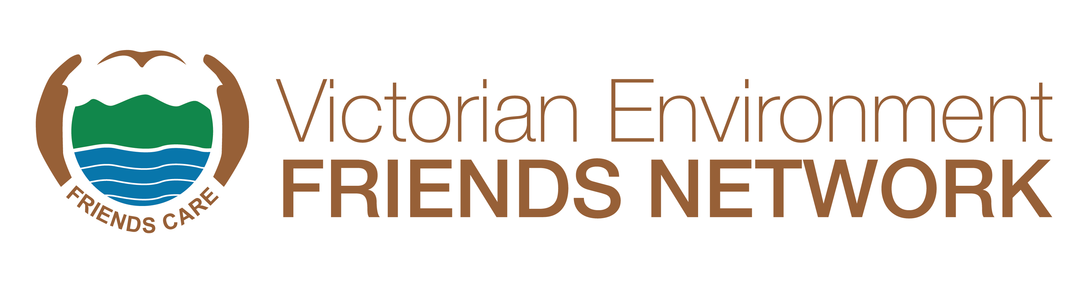
OUTSTANDING FRIENDS GROUP AWARD 2024
A champion team always beats a team of champions!
About the Category
The purpose of this award is to recognise that there are many people within a Friends group who contribute to a Friends group’s environmental achievements and successes. The Victorian Environment Friends Network (VEFN) is seeking nominations for this award for 2023.
Who can be Nominated
Nominations are open to a Friends group only. The Friends group can be any group of environmental volunteers who are actively working together to protect, restore, enhance and promote the Victorian natural environment or indigenous species and the need for its care. Friends groups can be nominated by people outside the group, or the Friends group can self-nominate.
Judging Panel
All nominations will be assessed by an independent judging panel against the Selection Criteria. Judges will make their decisions on whether the group meets the following Selection Criteria in a way that they perceive as ‘outstanding’.
Note - not all nominees will receive an award. The judging panel may make a special case for an additional award/s in the event of many deserving groups being nominated.
Completing the Nomination Form
The nomination form must be completed and signed by a recognised representative of the nominating friend group.
Please read the criteria carefully to ensure that your application is relevant. Please provide up to the allocated number of words in each area you feel is noteworthy. Be specific about the scale and impact of the contribution. A cursory response of a few lines with insufficient supporting material to enable a thorough assessment of the initiative will not be sufficient for the application to be considered. The quality and adequacy of information in the nomination form and attachments will have a bearing on the outcome. That is, it is not just what the initiative has achieved, but how well the information is understood and presented that will allow the judges to make their decision.



Selection Criteria
- Goals: Describe the Friends group’s clearly defined and documented environmental goals, objectives and/or strategic action plans. The goals need to be ambitious.
- Engagement: Describe how the Friends group meets regularly and works well together. E.g., through sharing work on projects and submissions. The sociability and vitality of the Friends group can be evidenced by personal statements from group members. There is general agreement by members about the activities of the Friends group. Describe how decision making is made in a way that maintains the cohesion and momentum of the group. Friends group members feel included and valued (as evidenced by surveys or interviews). The Friends group members share learning and members celebrate achievement of goals together.
- Achievements: Describe the Friends group’s documented evidence of its achievements over time or an important work in progress. The achievements need to be exceptional. A means of monitoring progress would be useful for judges to view. Please explain why your Friends group believes the achievements are exceptional.
- Succession: Describe how the Friends group engages with its community and actively recruits new members and encourages fresh ideas. This includes engaging and involving young people (children, teenagers, millennials) in a meaningful way. Describe how the Friends group can demonstrate that it actively works to keep the group effectively operating into the future through succession planning.
- Media: Describe how the Friends group has actively promoted its work and achievements in the media and attracted media attention. This includes social media.
- Community: Describe how and why the Friends group is well regarded within their communities.
- Other: Please add anything relevant to this award not covered by the above criteria
Referees
The nomination must include three (3) written references, including a reference from the agency land manager on their letterhead, where a Friends group has worked with an agency or state or local government.
Recent Photographs of Nominee
At least three high resolution (i.e., 1MB of more) electronic images of the nominee group working in the field must be included with the nomination.
PowerPoint and video presentation for winners
If your nominated Friends group is a winner or runner-up, we will need to know for the award ceremony if your group will be able to provide a PowerPoint or short 2-minute video to highlight the work undertaken by the group.
Successful Nominees
In the event of a Friends group receiving an Outstanding Environmental Group Award, any money that may be attached to the award will be paid to the nominating Friends group for the group to decide on how the funds will be spent.
Submission of nominations
Nominations can be entered via our website or emailed to awards@vefn.org.au with all supporting documentation attached. Please place ‘Outstanding Friends Group Award’ in the subject line.
Closing date for nominations is the 20th September at 5pm. Nominations received after the deadline will not be accepted.
If you have any questions, please contact Margaret Hunter (VEFN Secretary) on (03) 9587 0786 or Judith Baldacchino (VEFN Awards Subcommittee) on judith@vefn.org.au.
OUTSTANDING FRIENDS GROUP AWARD - NOMINATION FORM 2024
Nominating Friends Group:

Nominating Friends Group Contact:
Name:
Address:
Phone:
Email:

Nominee Friends Group:
Name:
Address:

Is the nominee group aware they have been nominated? YES/NO
Is your group able to make a PowerPoint/video presentation if your nominee group wins (highly recommended)? YES/NO

What year did the nominee group begin?

SELECTION CRITERIA
Describe the nominee group’s achievements with reference to the selection criteria.
Selection Criteria No 1 (max 200 words)

Selection Criteria No 2 (max 200 words)

Selection Criteria No 3 (max 200 words)

Selection Criteria No 4 (max 200 words)

Selection Criteria No 5 (max 200 words)

Selection Criteria No 6 (max 200 words)

Selection Criteria No 7 (max 200 words)

SPECIAL CONSIDERATIONS OR ADDITIONAL INFORMATION:

Referees:
All nominations must include written references, including from the agency land manager, where applicable. Please include contact details for each referee.

Name & Position:
Phone & Email:

Name & Position:
Phone & Email:

Name & Position:
Phone & Email:

Photo/s attached? YES/NO

Signed: Role: Date:

SUBMISSION OF NOMINATIONS
Checklist:
- Form filled in
- References provided
- Supplementary information attached
- Photos attached
- Signed
Nominations can be entered via our website or emailed to awards@vefn.org.au with all supporting documentation attached. Please place ‘VEFN Outstanding Friends Group Award’ in the subject line.
Closing date for nominations is the 20th September at 5pm. Nominations received after the deadline will not be accepted.
If you have any questions, please contact Margaret Hunter (VEFN Secretary) on (03) 9587 0786 or Judith Baldacchino (VEFN Awards Subcommittee) on judith@vefn.org.au.

