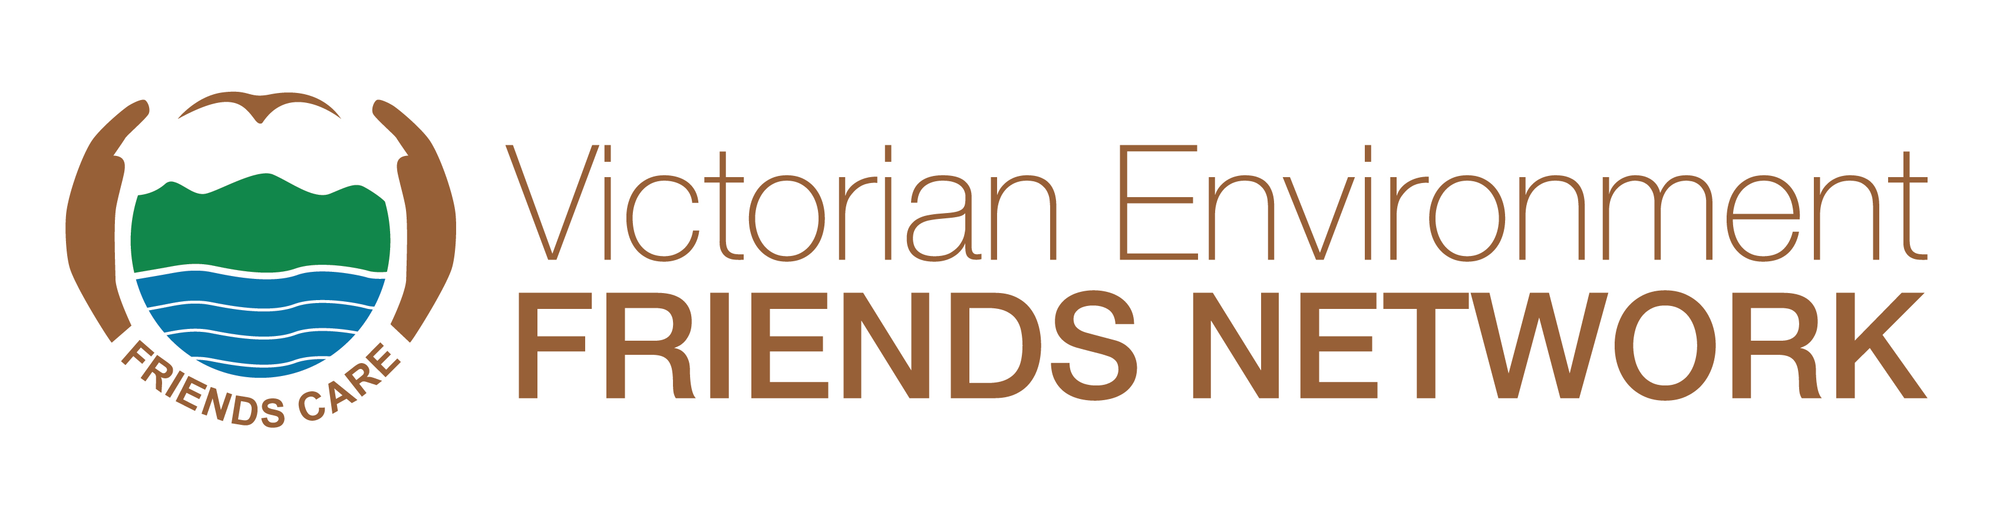
HABITAT CONNECTIONS AWARD 2024
About the Category
The Habitat Connections Award acknowledges the work done by environmental volunteers to connect habitat for native flora and fauna across patches of public and private land. The award recognises an outstanding project or initiative that has brought groups of environmental volunteers and government agencies together to improve and connect habitat across fragmented landscapes and has built knowledge about the connection of habitat, and fostered commitment to continue to work to improve habitat connections.
Who can be Nominated
Nominations are open to a representative of a habitat connection project or initiative, which should include a Friends group. The group can be any group of environmental volunteers who are actively working together to protect, restore, enhance and promote the Victorian natural environment or indigenous species and the need for its care.
Judging Panel
All nominations will be assessed by an independent judging panel against these selection criteria. Note: Not all nominees will receive an award. The judging panel may make a special case for additional awards in the event of many deserving initiatives being nominated.
Completing the Nomination Form
The nomination form must be completed and signed by a recognised representative of the nominating initiative.
Please read the selection criteria carefully to ensure that your nomination is relevant. Please provide up to the allocated number of words under each selection criteria. Be specific about the scale and impact of the contribution. A cursory response of a few lines with insufficient supporting material to enable a thorough assessment of the project or initiative will not be sufficient for the nomination to be considered. The quality and adequacy of information in the nomination form and attachments will have a bearing on the outcome. That is, it is not just what the project or initiative has achieved, but how well the information is understood and presented that will allow the judges to assess the nomination and make their decision.



Selection Criteria
The project or initiative will have made an outstanding contribution to connecting habitats, through the collaboration of environmental volunteers, groups and/or government agencies and others such as tertiary institutions as shown by the following selection criteria:
- Describe how the project or initiative has extended and connected habitat on public and/or private land (please describe habitat and targeted species) through activities such as planting, weeding, remnant tree protection, addition of hollows and nest boxes, pollination trails etc. Please describe what types of land and land tenure are involved and the area of habitat connected.
- Describe how the project or initiative formed strong relationships and partnerships between individual environmental volunteers, environmental volunteer groups, and agencies involved. At least one Friends group (as described for VEFN membership) must have been involved in the project or initiative. Please describe how you assess the project’s or initiative’s success, including what it means for future stewardship and habitat connection efforts.
- Describe the method(s) used for evaluating the impact of the project’s or initiative’s work to connect habitat and/or targeted species. Evidence of impact should be presented and why the nominee considers this important, relative to the stage and type of work.
- Describe how the project or initiative has improved knowledge about how habitat connection activities and collaborations can be undertaken, and how to effectively record and communicate this knowledge. Please describe the forms of knowledge and communication involved. Knowledge and communication may include: First Nations people, local, community, academic, scientific etc. Diverse voices and approaches will be well received.
- Describe how the project or initiative has communicated the value of the habitat connection and the collaboration, through websites, blogs, videos, talks and social media.
- Describe how this project or initiative has supported the long-term continuation and maintenance of work undertaken to meaningfully connect and enhance the habitat involved. What steps have been taken to future-proof the efforts?
Photographs
The nomination must include at least three high resolution electronic images (i.e., 1MB or more) of participants (preferably working in the field) or other aspects of the initiative that illustrate its work.
PowerPoint and Video Presentation for Winners
If your nominated initiative is a winner or runner-up, we will need to know for the award ceremony if your group will be able to provide a PowerPoint or short 2-minute video to highlight the work undertaken by the initiative.
Successful Nominees
In the event of an initiative receiving a Habitat Connection Award, any money that may be attached to the award will be paid to the winning Initiative for the group to decide on how the funds will be spent.

Submission of Nominations
Nominations can be entered via our website or emailed to awards@vefn.org.au with all supporting documentation attached. Please place ‘Best Friends Award’ in the subject line.
Closing date for nominations is the 20th September at 5pm. Nominations received after the deadline will not be accepted.
If you have any questions, please contact Margaret Hunter (VEFN Secretary) on (03) 9587 0786 or Judith Baldacchino (VEFN Awards Subcommittee) on judith@vefn.org.au.
HABITAT CONNECTIONS AWARD - NOMINATION FORM 2024

Nominating Group:

Nominating Group Contact:
Name:
Address:
Phone:
Email:

Nominated Initiative:
Name:
Address:
Project Name

Is the nominated initiative aware they have been nominated? YES/NO
Is your group able to make a PowerPoint/video presentation if your nominee group wins (highly recommended)? YES/NO

What year did the initiative begin?

SELECTION CRITERIA
Describe the initiative’s achievements with reference to the selection criteria.
Selection Criteria No 1 (max 200 words)

Selection Criteria No 2 (max 200 words)

Selection Criteria No 3 (max 200 words)

Selection Criteria No 4 (max 200 words)

Selection Criteria No 5 (max 200 words)

Selection Criteria No 6 (max 200 words)

SPECIAL CONSIDERATIONS OR ADDITIONAL INFORMATION:

Referees:
All nominations must include written references, including from the key involved agencies and environment groups. Please include contact details for each referee. Add additional boxes if required.

Environmental
Group or
Agency
Name & Position:
Phone & Email:

Environmental
Group or
Agency
Name & Position:
Phone & Email:

Environmental
Group or
Agency
Name & Position:
Phone & Email:

Photo/s attached? YES/NO

Signed: Role: Date:

SUBMISSION OF NOMINATIONS
Checklist:
- Form filled in
- References provided
- Supplementary information attached
- Photos attached
- Signed

Nominations can be entered via our website or emailed to awards@vefn.org.au with all supporting documentation attached. Please place ‘Best Friends Award’ in the subject line.
Closing date for nominations is the 20th September at 5pm. Nominations received after the deadline will not be accepted.
If you have any questions, please contact Margaret Hunter (VEFN Secretary) on (03) 9587 0786 or Judith Baldacchino (VEFN Awards Subcommittee) on judith@vefn.org.au.

