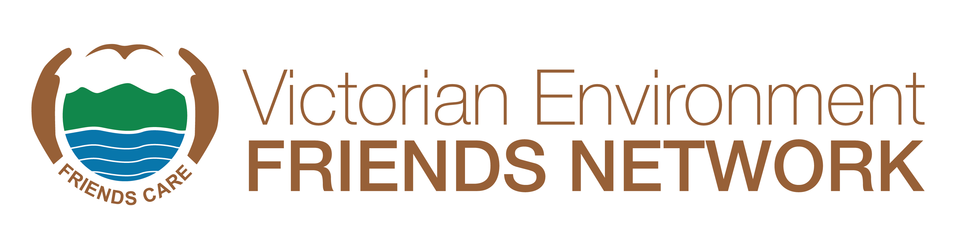
CDS VIC LITTER AWARD 2024
About the Category

The CDS Vic Litter Award acknowledges the hard work performed by environmental volunteers to keep their special patch of bushland, coastline or waterway free from litter. Although litter is a societal problem, this award rewards groups who are actively addressing the issue through initiatives that involve prevention, education, and clean-ups and are integrating recycling with CDS Vic in these initiatives.
This award acknowledges the sponsorship of Victoria’s Container Deposit Scheme (CDS Vic) and their commitment to engaging the community to recycle.
Friends groups can recycle eligible 10c drink containers and raise important funds to support their conservation funds. It only takes a few minutes to sign up with CDS Vic:
- Register on the CDS Vic website to receive a ‘donation partner’ ID
- Activate the ‘donation partner’ ID with your local zone operator to receive funds donated by the community
To learn more, visit https://cdsvic.org.au/fundraising
Who can be nominated
Nominations are open to a representative of a litter minimisation project or initiative, which should include a Friends group.
Eligibility:
- The Friends group is (or will be) registering as a donation partner with CDS Vic. Sign up with CDS Vic here. To learn more about fundraising with CDS Vic, head to: https://cdsvic.org.au/fundraising.

- The Friends group is (or will be) actively collecting and returning eligible drink containers.

- The refunds received from returning eligible drink containers are used (or will be using) for funding the Friend group’s on the ground conservation efforts.

Judging Panel

All nominations will be assessed by an independent judging panel against these selection criteria. Note: Not all nominees will receive an award. The judging panel may make a special case for additional awards in the event of many deserving initiatives being nominated.
Completing the Nomination Form
The nomination form must be completed and signed by a recognised representative of the nominating initiative.


Please read the selection criteria carefully to ensure that your nomination is relevant. Please provide up to the allocated number of words under each selection criteria. Be specific about the scale and impact of the contribution. A cursory response of a few lines with insufficient supporting material to enable a thorough assessment of the project or initiative will not be sufficient for the nomination to be considered. The quality and adequacy of information in the nomination form and attachments will have a bearing on the outcome. That is, it is not just what the project or initiative has achieved, but how well the information is understood and presented that will allow the judges to assess the nomination and make their decision.
Selection Criteria

The project or initiative will have made an outstanding contribution to keeping an area as pristine and free from litter as possible as shown by the following selection criteria:
- What initiatives has your group used to address litter in your area? For example: Involvement with Clean Up Australia Day, Litter Blitzes, Litter Groups (If possible, include dates and estimations of how many people were involved).

- Demonstrate how the litter project embedded (or will embed) the practice of collecting and returning eligible CDS Vic drink containers? Briefly describe how much money your group has raised via CDS Vic and how the funds help your group’s conservation efforts?

- Describe how the initiative and the role of CDS Vic within it has been communicated through websites, blogs, videos, talks and social media to the wider community.

- Describe the litter prevention strategies your group has employed to keep litter from entering your area and how they are designed to have a long-term impact. For example: education, signage, engaging with litter sources, building relationships with authorities

- Describe the methodology used for evaluating the impact of the projector initiative to remove litter. For example, before and after photographs, litter data comparisons.

- List the positive benefits of litter removal to your specific habitat.

Photographs
The nomination must include at least three high resolution electronic images (i.e., 1MB or more) of participants (preferably working in the field) or other aspects of the initiative that illustrate its work.
PowerPoint and Video Presentation for Winners
If your nominated initiative is a winner, we will need to know for the award ceremony if your group will be able to provide a PowerPoint or short 2-minute video to highlight the work undertaken by the initiative.
Successful Nominees
In the event of an initiative receiving a Habitat Connection Award, any money that may be attached to the award will be paid to the winning Initiative for the group to decide on how the funds will be spent.
Submission of Nominations
Nominations should be emailed to awards@vefn.org.au with all supporting documentation attached. Please place ‘CDS Vic Litter Award’ in the subject line.
Closing date for nominations is the 20th September at 5pm. Nominations received after the deadline will not be accepted.
If you have any questions, please contact Margaret Hunter on (03) 9587 0786 or Judith Baldacchino on judith@vefn.org.au.

CDS VIC LITTER AWARD - NOMINATION FORM 2024

Nominating Group:

Nominating Group Contact:
Name:
Address:
Phone:
Email:

Nominated Initiative:
Name:
Address:
Project Name

Is the nominated initiative aware they have been nominated? YES/NO
Is your group able to make a PowerPoint/video presentation if your nominee group wins (highly recommended)? YES/NO

What year did the initiative begin?

SELECTION CRITERIA
Describe the initiative’s achievements with reference to the selection criteria.
Selection Criteria No 1 (max 500 words)

Selection Criteria No 2 (max 100 words)

Selection Criteria No 3 (max 100 words)

Selection Criteria No 4 (max 100 words)

Selection Criteria No 5 (max 100 words)

Selection Criteria No 6 (max 100 words)

SPECIAL CONSIDERATIONS OR ADDITIONAL INFORMATION:

Referees:
All nominations must include written references, including from the key involved agencies and environment groups. Please include contact details for each referee. Add additional boxes if required.

Environmental
Group or
Agency
Name & Position:
Phone & Email:

Environmental
Group or
Agency
Name & Position:
Phone & Email:

Environmental
Group or
Agency
Name & Position:
Phone & Email:

Photo/s attached? YES/NO

Signed: Role: Date:

SUBMISSION OF NOMINATIONS
Checklist:
- Form filled in
- References provided
- Supplementary information attached
- Photos attached
- Signed

Nominations should be emailed to awards@vefn.org.au with all supporting documentation attached. Please place ‘CDS Vic Litter Award’ in the subject line.
Closing date for nominations is the 20th September at 5pm. Nominations received after the deadline will not be accepted.
If you have any questions, please contact Margaret Hunter on (03) 9587 0786 or Judith Baldacchino on judith@vefn.org.au.

